### [https://aws.amazon.com/free/?all-free-tier.sort-by=item.additionalFields.SortRank&all-free-tier.sort-order=asc&awsf.Free%20Tier%20Types=*all&awsf.Free%20Tier%20Categories=*all&awsm.page-all-free-tier=2](https://aws.amazon.com/free/?all-free-tier.sort-by=item.additionalFields.SortRank&all-free-tier.sort-order=asc&awsf.Free%20Tier%20Types=*all&awsf.Free%20Tier%20Categories=*all&awsm.page-all-free-tier=2)

### 1. Create a free aws account by clicking on "Create Free Account" https://aws.amazon.com/free/

https://aws.amazon.com/resources/create-account/

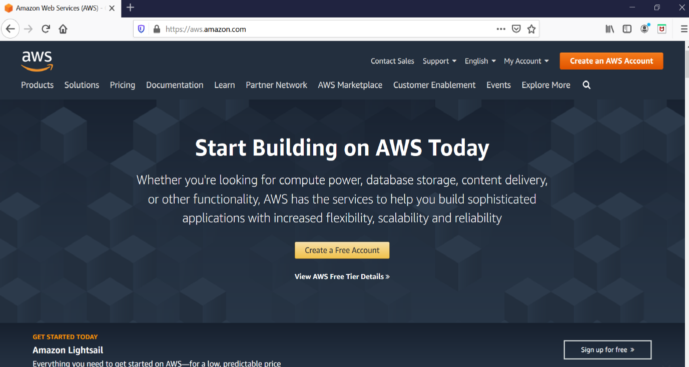

### 2. Fill your details to create an account. Details required are Email address and account name of your choice.

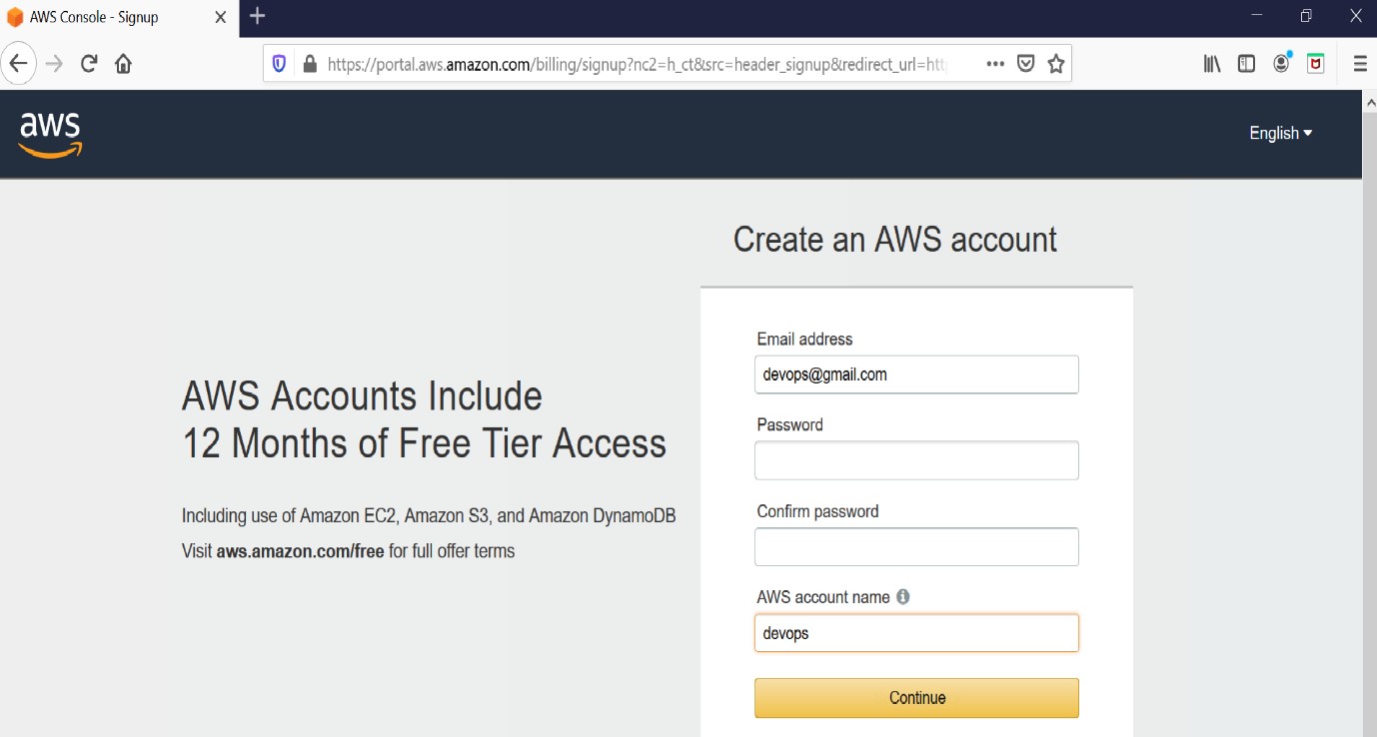

### 3. After submitting the data you will be taken to SignUp form which requires more details.

**Select Account Type as `Personal`.Your address and Mobile number. (Need to provide a valid mobile number, You will receive a call in further setup)**

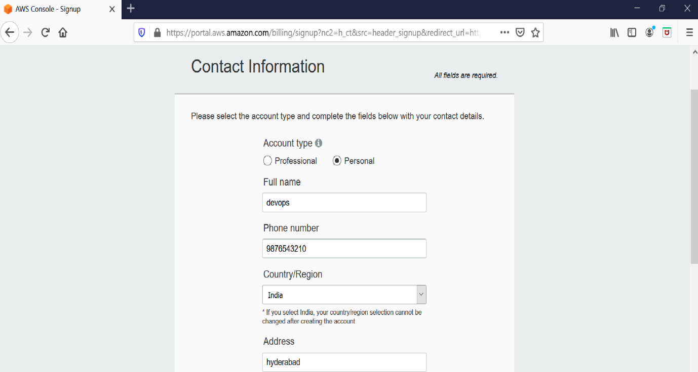

### 4. Next you will be prompt to provide the credit card details. So proceed by providing the details.

**Provide credit/debit card details.**

**Select PAN number as NO**

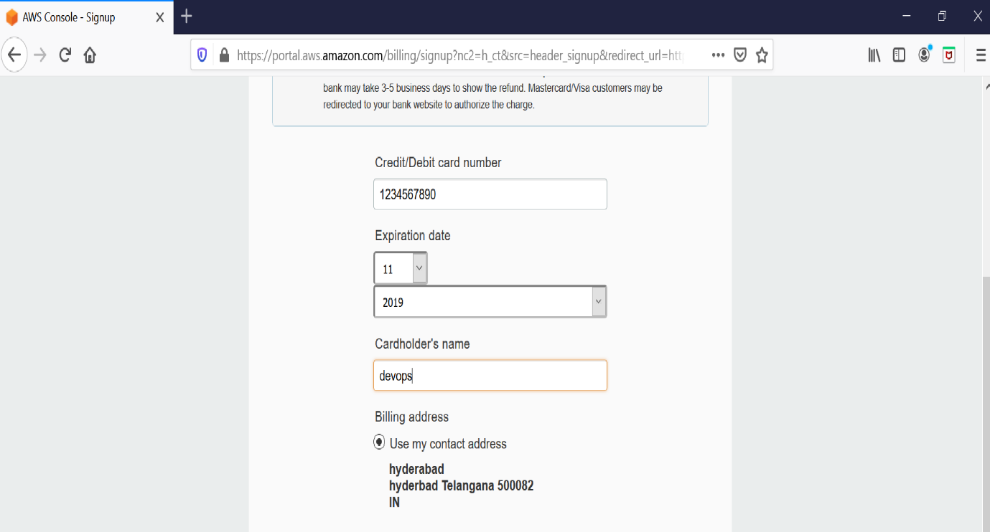

### 5. You will be redirected to your bank payment portal to provide OTP and after that select the plan as Basic.

### 6. Once your account is completed use the following link

<https://aws.amazon.com/console/> **and sign in to the console**.

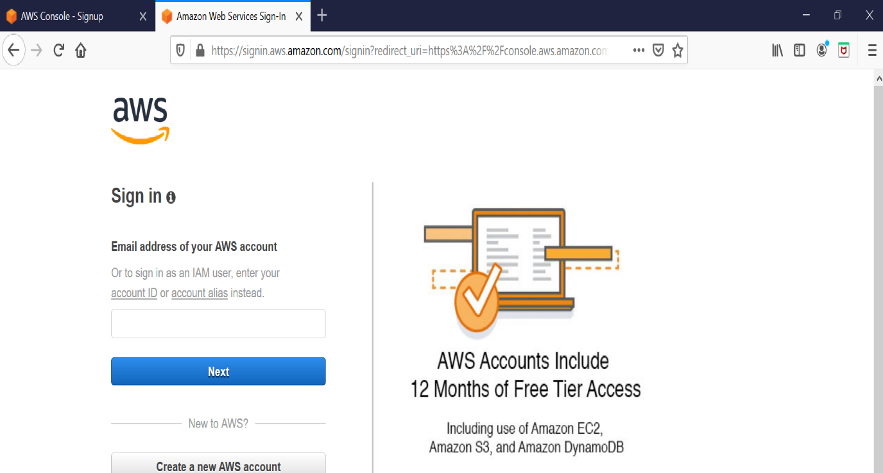

**7. In the search box, search EC2 and click on it.**

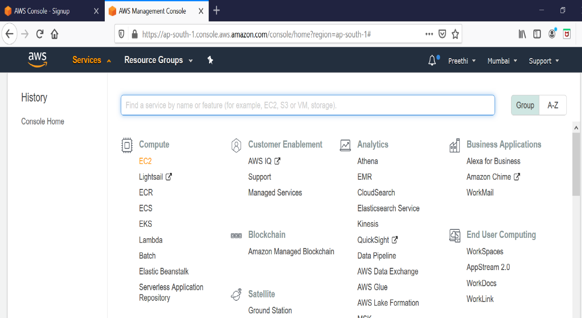

**8. Click on launch Instance**.

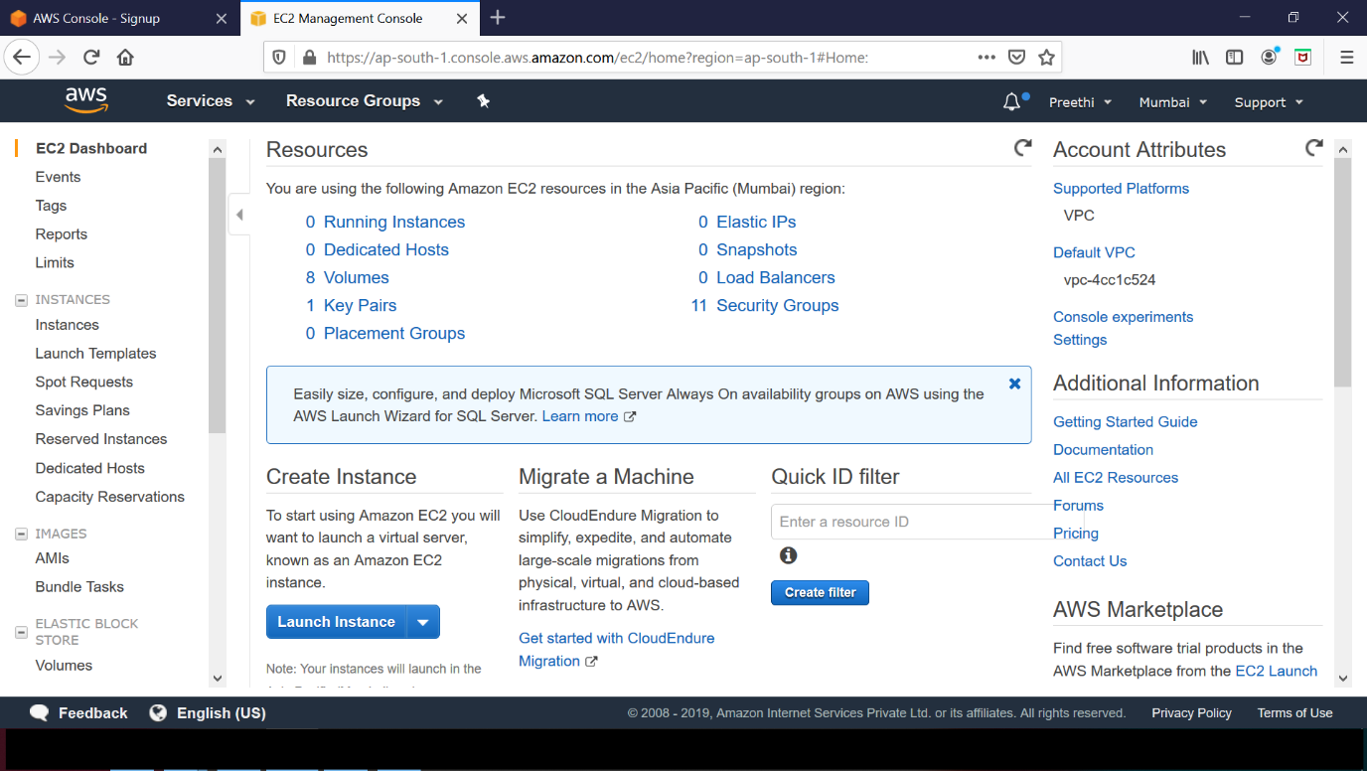

**9. Select “Amazon Linux 2 AMI”**

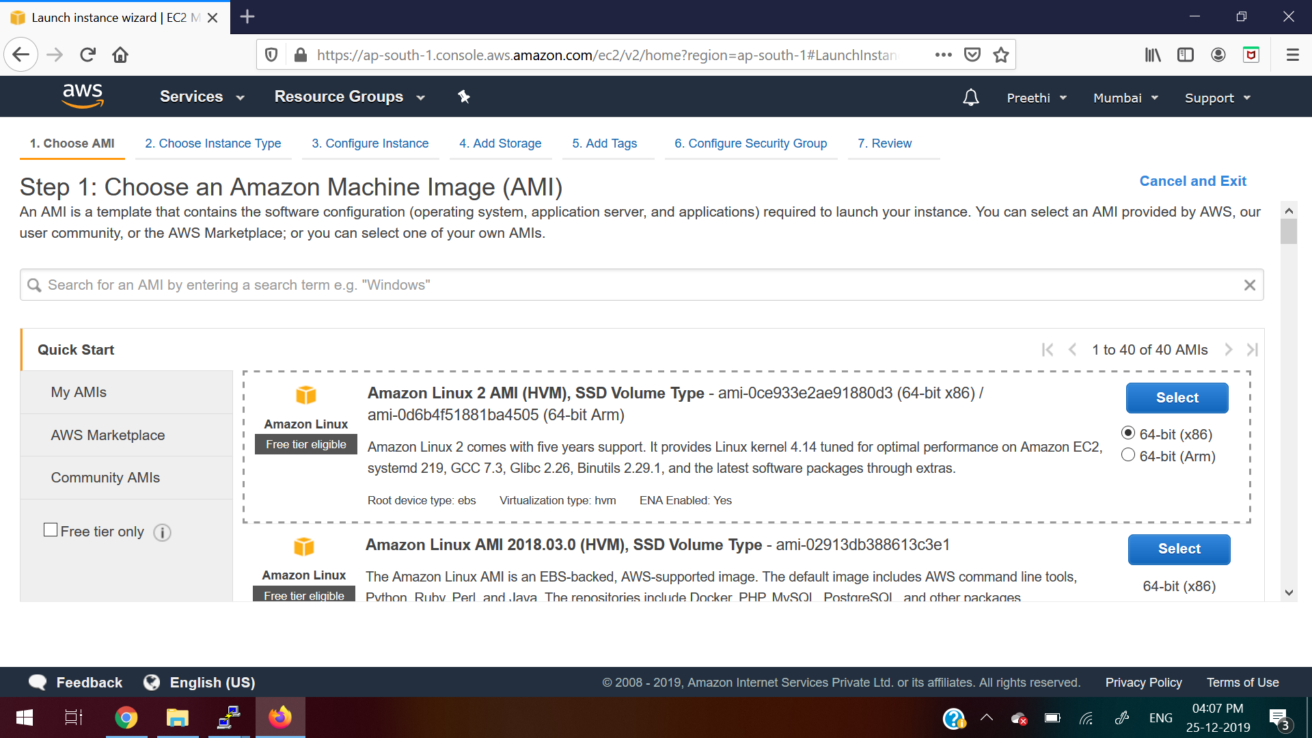

**10. Keep it as default (Don’t do any changes)**

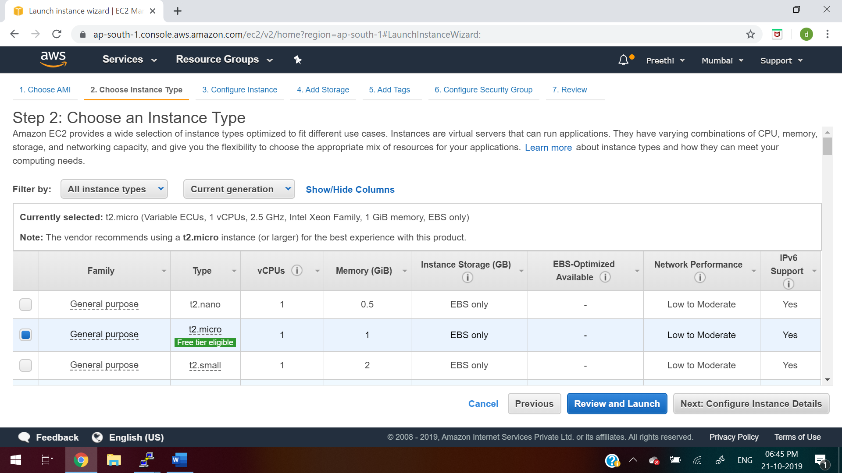

**11. Keep it as default (Don’t do any changes)**

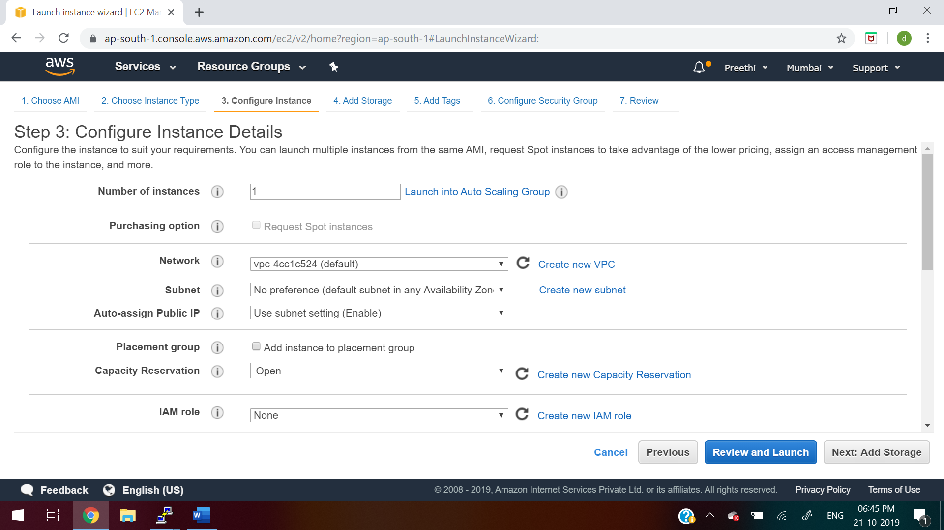

**12. Keep it as default (Don’t do any changes)**

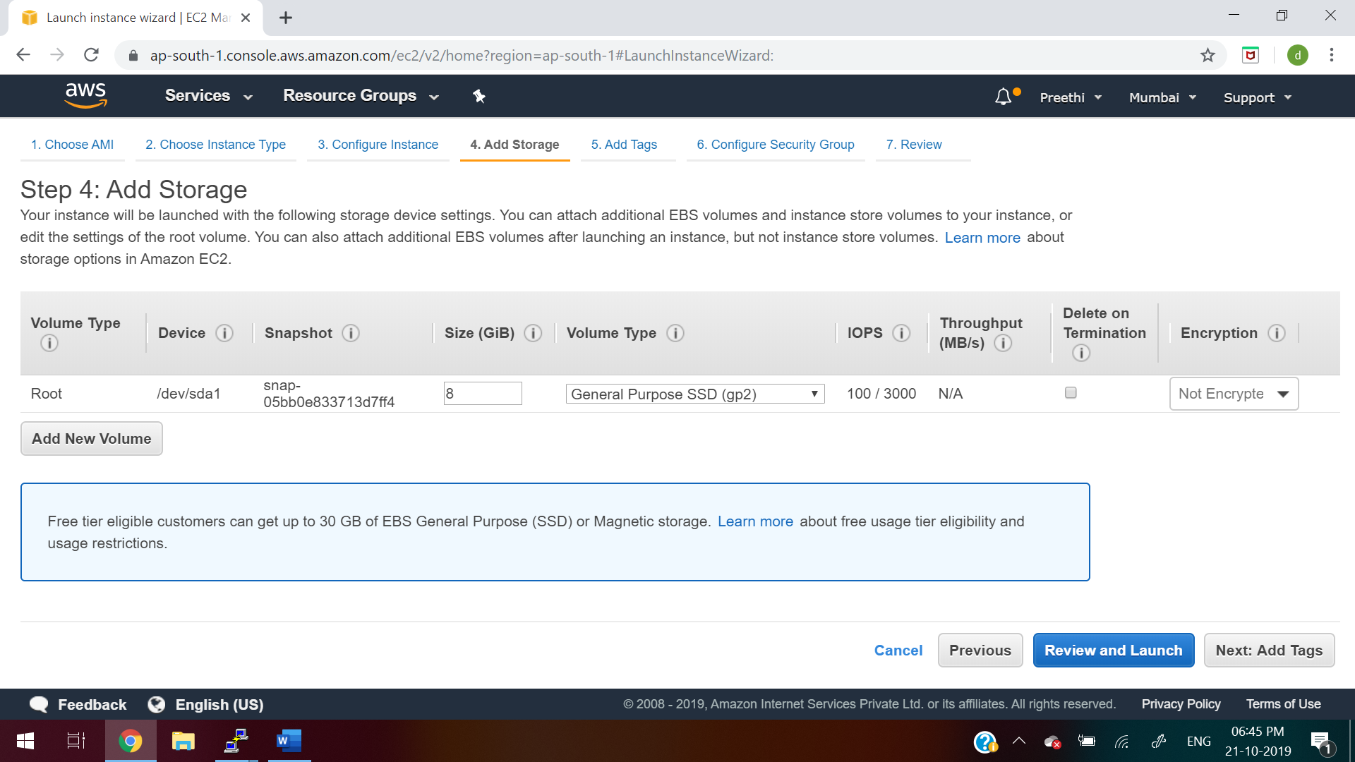

**13. Keep it as default (Don’t do any changes)**

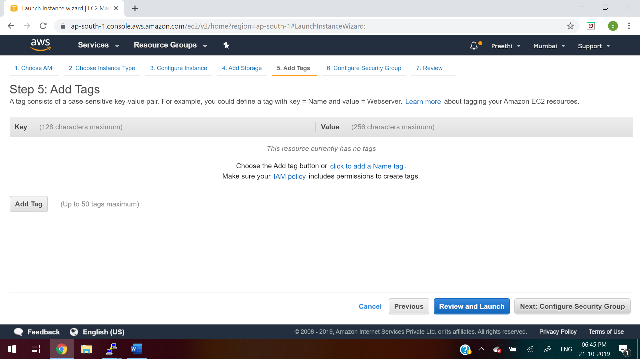

**14. click on “Add Rule” button as below and click on “Review and Launch”**

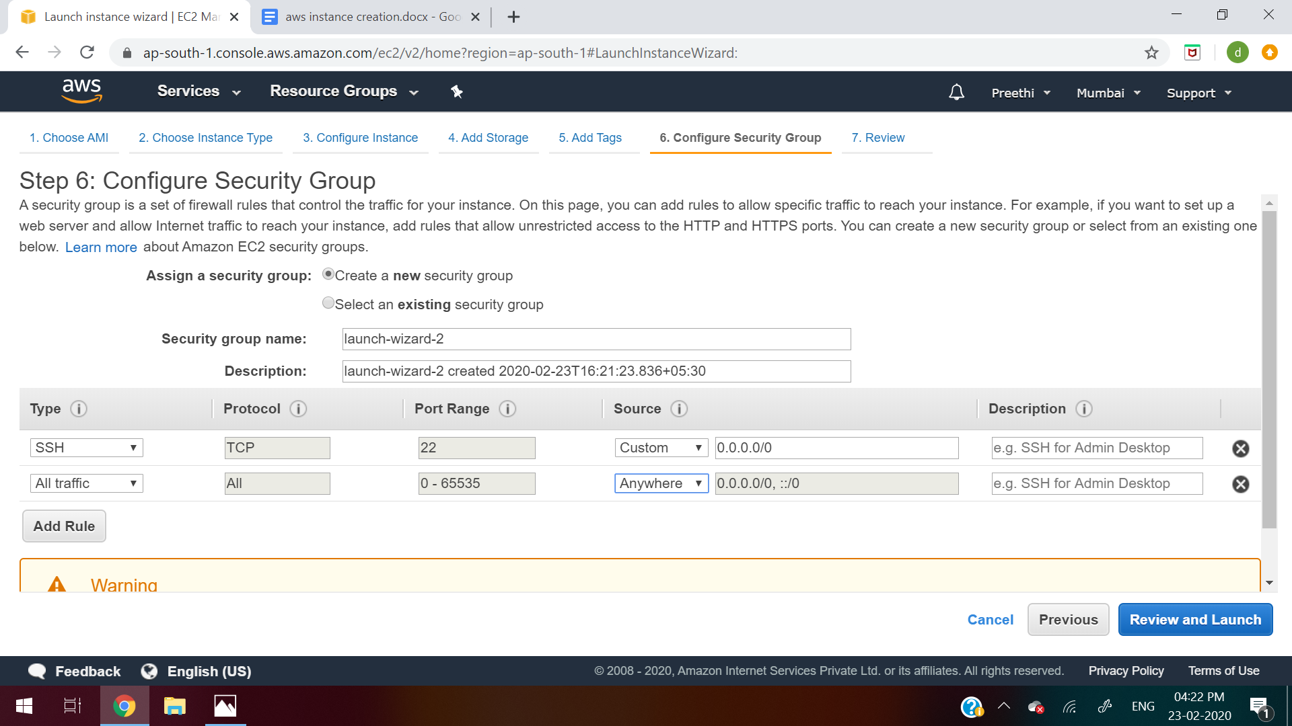

**15. Click on Launch**

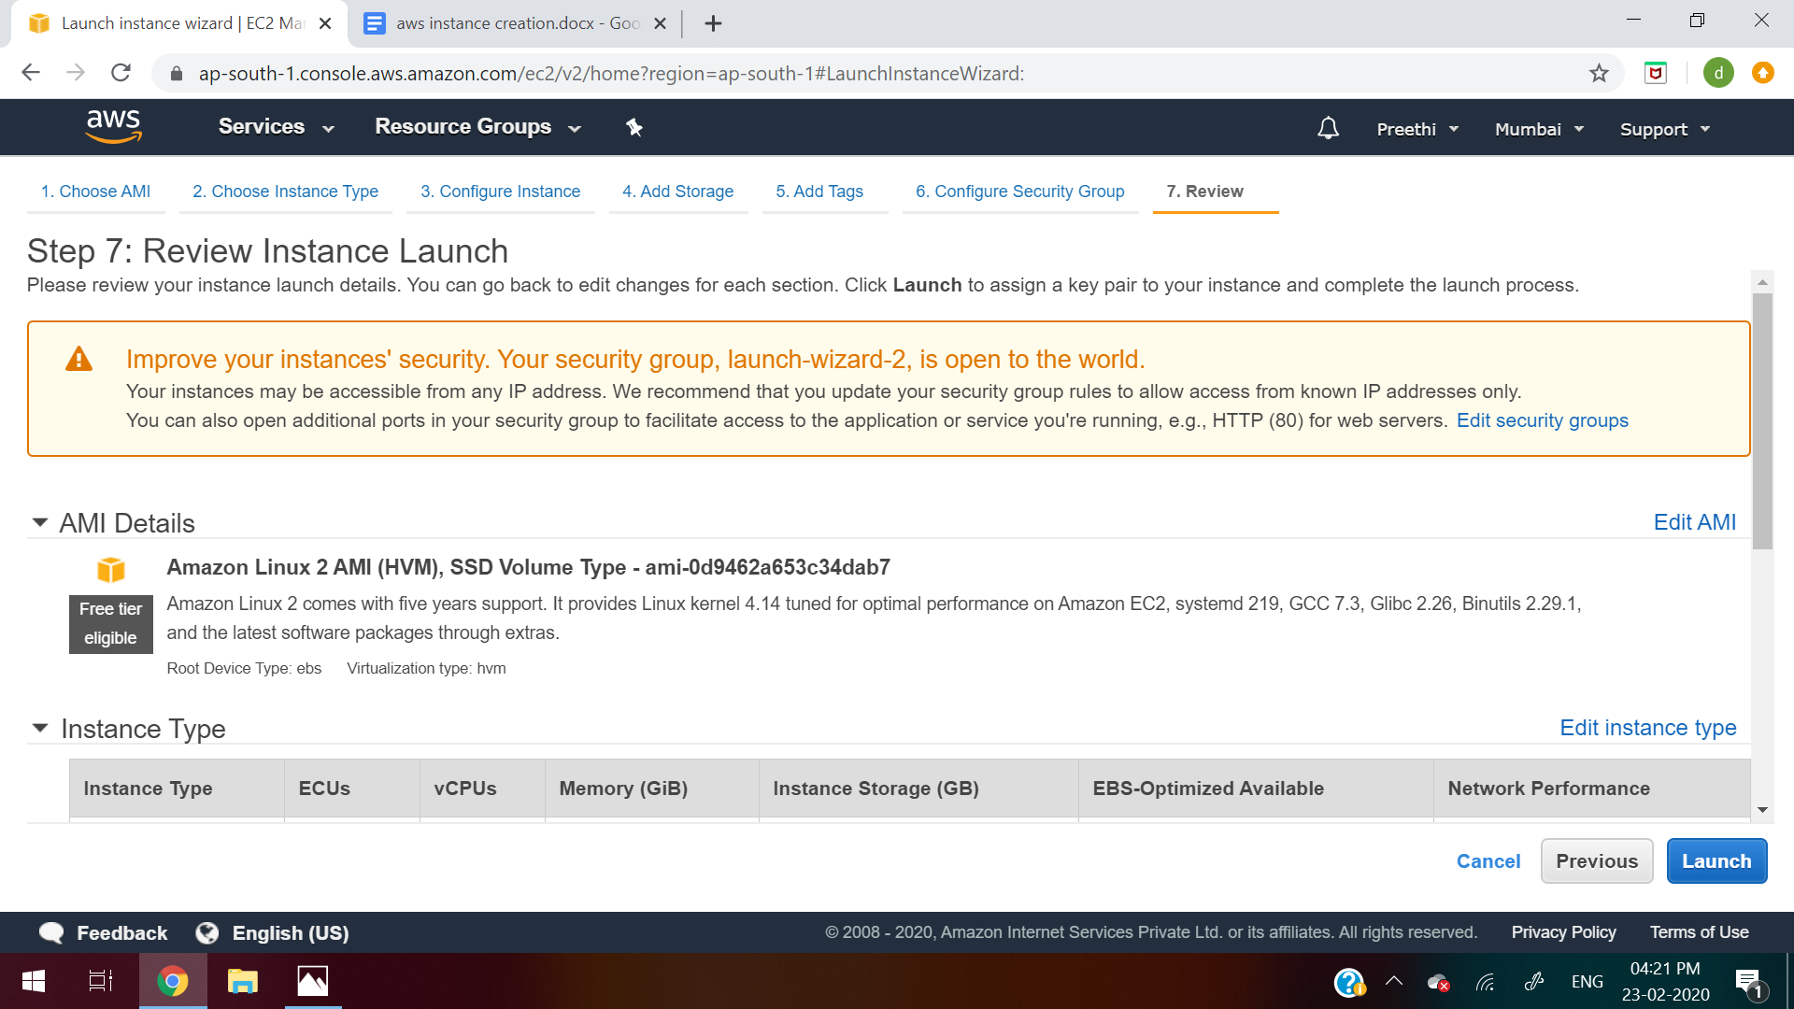

**16. Click on “Create a new key pair”**

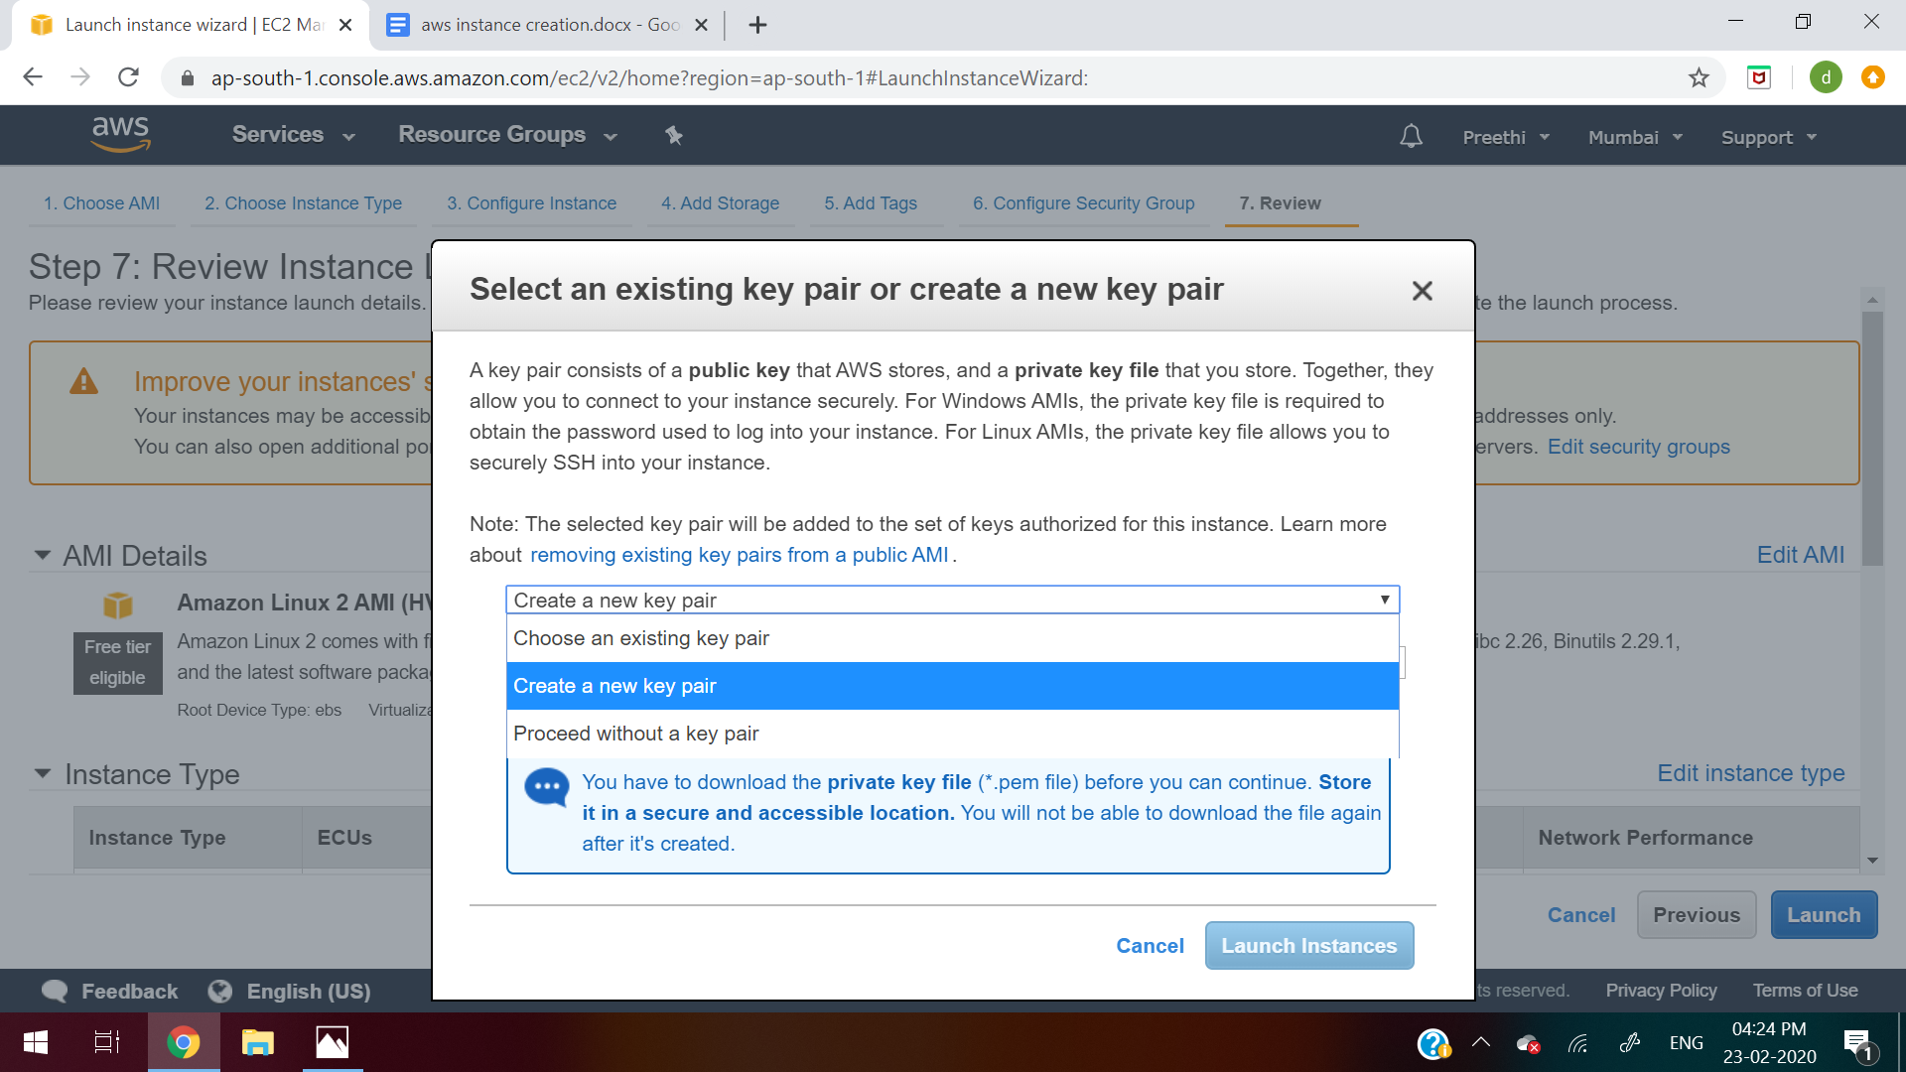

**17.Give some name to the keypair like “aws_key” and then click on “Download the Keypair”**

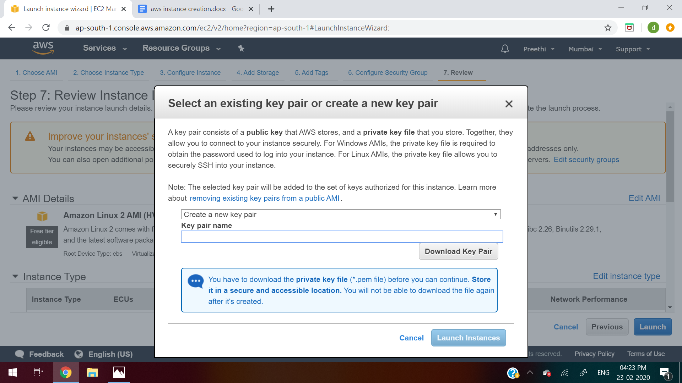

**18. Click on Launch Instance**

